**MGMT 590: Using R for Analytics**

**Team Shiny DSS Final Project**

**Description**

Over the course of this term you have learned some functionality of RStudio to do various analytical tasks such as summarizing data with statistics, graphical visualizations, creating functions to achieve some task, as well as examples of descriptive, predictive, and prescriptive analytics. Your team needs to describe a business problem, function, or operation that could be better supported via a decision-support tool created using Shiny in RStudio.

A decision-support system (DSS) usually contains three components (1) a data component such as database, (2) a model component that helps to support the problem, and (3) a graphical user interface (GUI) component that allows the decision-maker to interact with the model or data, such as specifying parameters, etc.

You do not need to create a relational database, but you will need to find a dataset or simulate one that your model and GUI will use to demonstrate your DSS prototype. Your DSS app should contain at least one kind of model (e.g. clustering, prediction, or optimization). Your DSS might even contain multiple models, such as both clustering and prediction, or prediction with optimization. Whatever methodology you choose to use to support the problem, make sure you can tell explain why you chose to use it.

Your GUI should be an R Shiny app that does something useful to help support a decision and where the end-user can specify parameters and run the tool so as to help provide them information that will help support their decision-making. See <http://shiny.rstudio.com/gallery/> for examples you might modify to develop your DSS. A Shiny cheat sheet can be found [here](https://www.rstudio.com/wp-content/uploads/2016/01/shiny-cheatsheet.pdf), as well as some [videos](https://www.rstudio.com/resources/webinars/) you might find useful. Here are a couple Shiny apps that students created last year that were pretty good. Their presentation of them was fantastic.

* <https://rated-r.shinyapps.io/Home_Improvement_DSS_App/>
  + [Additional information about it](http://matthewalanham.com/Students/2017_Abhishek-Komal-Akshay.pdf)
* <https://felipecamachoc.shinyapps.io/R_FinalProject/>

**Read the grading rubric below carefully**. Your DSS prototype need not be extremely sophisticated. The important thing is you justify the need for it and provide some feature(s) necessary to help the decision-maker. The questions you answer below are important ones that you will be required to answer in developing DSSs in practice.

**Teams**

You must form teams consisting of 3-5 members by Monday, September 11th and post at least your team name and team members. By Monday, September 18th, I want a description of your project. You will add this information in Blackboard under the “Project Teams & DSS” tab. Just click “Edit Wiki Content” to add your team and info as shown below.

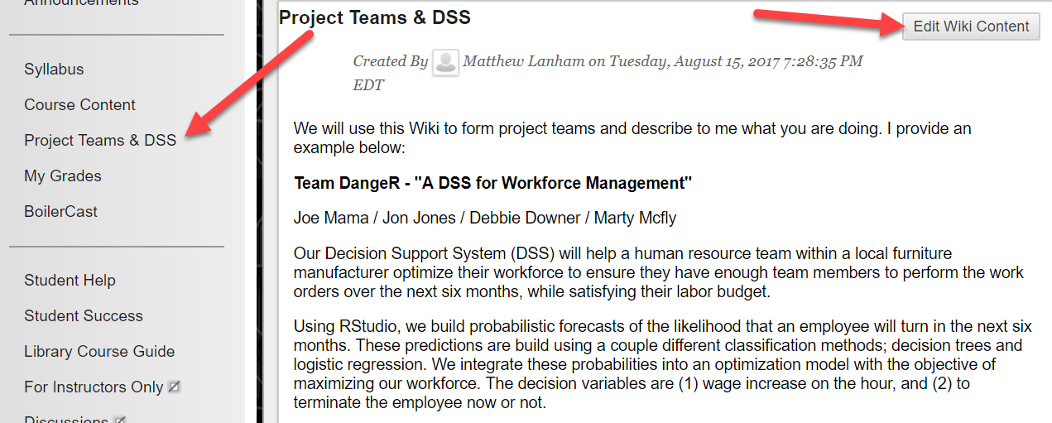

**Due Date**

Your team will have one submission that is due by the start of class on **Wednesday, October 4th**. The submission must include (1) a write-up (see attached template), (2) a link to your code on someone’s GitHub account, and (3) a link of your working app on http://www.shinyapps.io/.

Also, every student must also email me the scores they give their teammates based on the posted team evaluation form on Blackboard. The scores and feedback you provide me about your teammates will be confidential and will not be shared with anyone.

**Presentation**

Every team must present a short demonstration of their DSS in class either Monday, October 2nd or Thursday, October 6th. The first four teams that volunteer to present early on October 2nd, will automatically receive 5% extra credit on this assignment. I offer this opportunity because we will not have time for all 8 or 9 times to present in the same day.

Each team presentation should be no more than 12 minutes long. I will call on teams randomly at the beginning of these presentation days to demonstrate their work. Make sure the demonstration of the app is equal among the team. Time is short, so really hit on the key points on each section below.

**Grading Rubric**

|  |  |  |  |  |
| --- | --- | --- | --- | --- |
|  | **Total Potential Points** | **Exemplary** | **Proficient** | **Developing** |
| Business Problem Definition | ___/10 | **10**   * A clear and concise description of the business problem * Identification of Stakeholders * Discussion whether the problem is amenable to an analytics solution * Refinement of the problem to identify any delineate constraints * Define the initial set of business benefits * Statement claiming that stakeholder agreement on the business problem statement has been determined | **7.5**   * A broad or unclear description of the business problem * Missing one of the other bullets | **5**   * Extremely broad or unclear description of the business problem * Missing more than one of the other bullets |
| Analytics Problem  Definition | ___/10 | **10**   * Reformulate problem statement as an analytics problem * Develop a proposed set of drivers and relationships to outputs * State the key set of assumptions related to the problem * Define key metrics of success * Statement claiming stakeholder agreement on the approach | **7.5**   * Unclear description of problem statement as an analytics problem * Missing one of the other bullets | **5**   * Poor description of problem statement as an analytics problem * Missing more than one of the other bullets |
| Data | ___/5 | **5**   * A discussion that identifies and prioritizes data needs and sources * Acquire data that is actually available * Harmonize, rescale, clean, and share data in your DSS * Identify relationships in the data * Document and report findings (e.g., insights, results, business performance) * Refine the business and analytics problem statements (if needed) | **2.5**   * Poor discussion about what data is best, the data you can get, and if it sufficient to support the decision * Missing one of the other bullets | **0**   * A lack of discussion about what data is best, the data you can get, and if it sufficient to support the decision * Missing more than one of the other bullets, especially review of the data |
| Methodology  Selection | ___/10 | **10**   * Identify a few problem solving approaches (methods) and use one or two * Discuss why R is a viable tool to use * Test and select an approach or approaches you believe might work | **7.5**   * Identifies only one potential method * Missing one of the other bullets | **5**   * Missing two or more bullets |
| Model Building | ___/10 | **10**   * Run and evaluate the model(s) * Calibrate model and data * Discussion of integrating the model back to the problem * Discussion of any findings (including assumptions, limitations, and constraints) | **7.5**   * Missing one of the following bullets | **5**   * Missing more than one of the following bullets |
| Functionality | ___/15 | **15**   * Discuss what the DSS can do * Discuss any R packages you found useful * Did you have to write any conditional logic? * If you had more time or experience, what other enhancements might you like to add? | **10**   * Unclear discussion of what the DSS can do * Missing one of the other bullets | **5**   * Poor discussion of what the DSS can do * Missing more than one of the other bullets |
| GUI Design & Quality | ___/15 | **15**   * Does the tool work without errors? * Does it appear as good or better than the provided Shiny student examples from last year? | **10**   * Tool works but has obvious errors * Appears as good or better than the provided Shiny student examples from last year? | **5**   * Tool works but has obvious errors or does not work at all * Does not appear as good or better than the provided Shiny student examples from last year? |
| Team Feedback | ___/10 | The average score provided from your teammates about your effectiveness as a teammate | | |
| Class Evaluation | ___/10 | After all team app presentations are complete, every student will rank each team’s overall app and presentation of it from best to worst. | | |
| My Evaluation of your presentation | ___/5 | After all team app presentations are complete, I will rank each team’s overall app and presentation of it from best to worst. | | |
| **TOTAL POINTS** | **___/100** |  |  |  |